POWER REDUCTION POTENTIAL OF COORDINATED CEILING AND TASK LIGHTING UNDER VARIABLE DAYLIGHT AND OCCUPANCY

Kefan Chen^{1,}*, Guanli Feng¹, Yu Qian Ang¹, Adrian Chong¹

¹College of Design and Engineering, National University of Singapore, Singapore.

ABSTRACT
Traditional indoor lighting design is typically based on full-load occupancy, whereas actual workplace occupancy varies in both density and spatial distribution. This mismatch may waste power by over illuminating spaces already served by other environmental lighting. Ceiling lighting provides ambient illumination at the space scale, whereas task lighting addresses localized visual needs. We therefore developed a Balanced Light Control Framework that coordinates these central and local systems to minimize lighting power while maintaining visual comfort. A Singapore office laboratory with three ceiling-light zones and 24 task lights was simulated under Clear, Overcast, and Night conditions for 1–15 occupants. Five matched seating layouts at each occupancy count yielded 225 scenarios. We applied a penalty-based genetic algorithm to identify low-power configurations satisfying the illuminance and uniformity requirements from SS 531. These configurations, defined as optimized hybrid control, were compared with zonal PIR ceiling-only control and rule-based hybrid control. Relative to zonal Passive Infrared Sensors (PIR), optimized hybrid control reduced mean lighting power by 76.9% under Clear, 62.0% under Overcast, and 46.8% at Night. Relative to rule-based hybrid control, it reduced mean power by 22.5% under Overcast and 25.0% at Night, while remaining at a similarly low level under Clear. The optimized configurations relied mainly on task lighting under Clear and selectively combined ceiling and task lighting under Overcast and Night. Overall, coordinating central and local lighting substantially reduced lighting power while maintaining visual comfort, though the achievable reduction depended on daylight and seating layout.

KEYWORDS
Lighting control, Daylight responsive, Lighting power optimization, Visual comfort, Genetic algorithm

INTRODUCTION
Office lighting systems are commonly designed for full occupancy, although actual workplace use varies in both occupant number and location over time (Tekler et al. 2022). Consequently, schedule based or aggregate occupancy controls may illuminate unoccupied areas or workstations already adequately served by the environmental lighting like the daylight and other ceiling lights. Effective lighting control must therefore respond to daylight availability as well as the number and location of occupants.
Coordinating lighting at different spatial scales offers a potential solution. Ceiling luminaires provide ambient illumination and spatial uniformity, whereas task lights deliver localized illumination to individual worktables and support personal adjustment (De Korte et al. 2015). Previous studies have shown that high-resolution daylight and occupancy sensing can restrict electric lighting to occupied areas (Lowcay et al. 2020), while localized task-light control can further reduce lighting power (Papinutto et al. 2021). However, ceiling and task lighting are generally evaluated as separate systems. It therefore remains unclear how they should be coordinated and the saving potential of it when daylight, occupancy count, and seating layout vary simultaneously.

To address this gap, this study develops a Balanced Light Control Framework to evaluate the power reduction potential of coordinated ceiling and task lighting while maintaining visual comfort requirement on illuminance and uniformity from SS531 (Singapore Standards Council 2006). The framework evaluates optimized hybrid control across matched combinations of sky condition, occupancy count, and seating layout, and compares it with zonal PIR ceiling-only control and rule-based hybrid control. This comparison quantifies the achievable lighting power reduction and reveals how the balance between ceiling and task lighting changes across operating conditions.

METHODS
Optimization workflow
Figure 1 summarizes the scenario definition, control optimization, and benchmark comparison. Each scenario combines the office model, a sky condition, an occupancy count, and a seating layout, while the corresponding control specifies three ceiling-light zones and 24 task lights (Figure 1(a,b)). ClimateStudio evaluates visual comfort and lighting power, after which the Galapagos Algorithm (GA) identifies the lowest-power feasible configuration (Figure 1(c–e)). The resulting optimized hybrid control is then compared with zonal PIR ceiling-only control and rule-based hybrid control under the same scenario (Figure 1(f,g)).

Case-study model and lighting systems
The case study represented one open-plan office laboratory within a larger Singapore university building. Figure 2 locates the simulated room within the host model. As shown in Figure3, the room contains 24 fixed workstations, each with an independently adjustable task light. Ceiling lighting is divided into three zones serving seats 0–7, 8–15, and 16–23. ClimateStudio calculated illuminance and uniformity for occupied task areas and their surroundings.
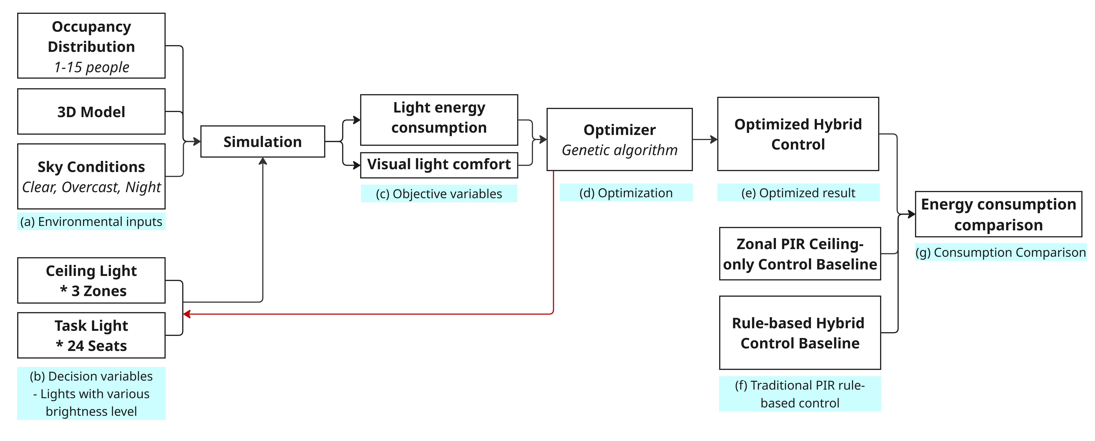
Figure 1. Workflow for evaluating the Balanced Light Control Framework
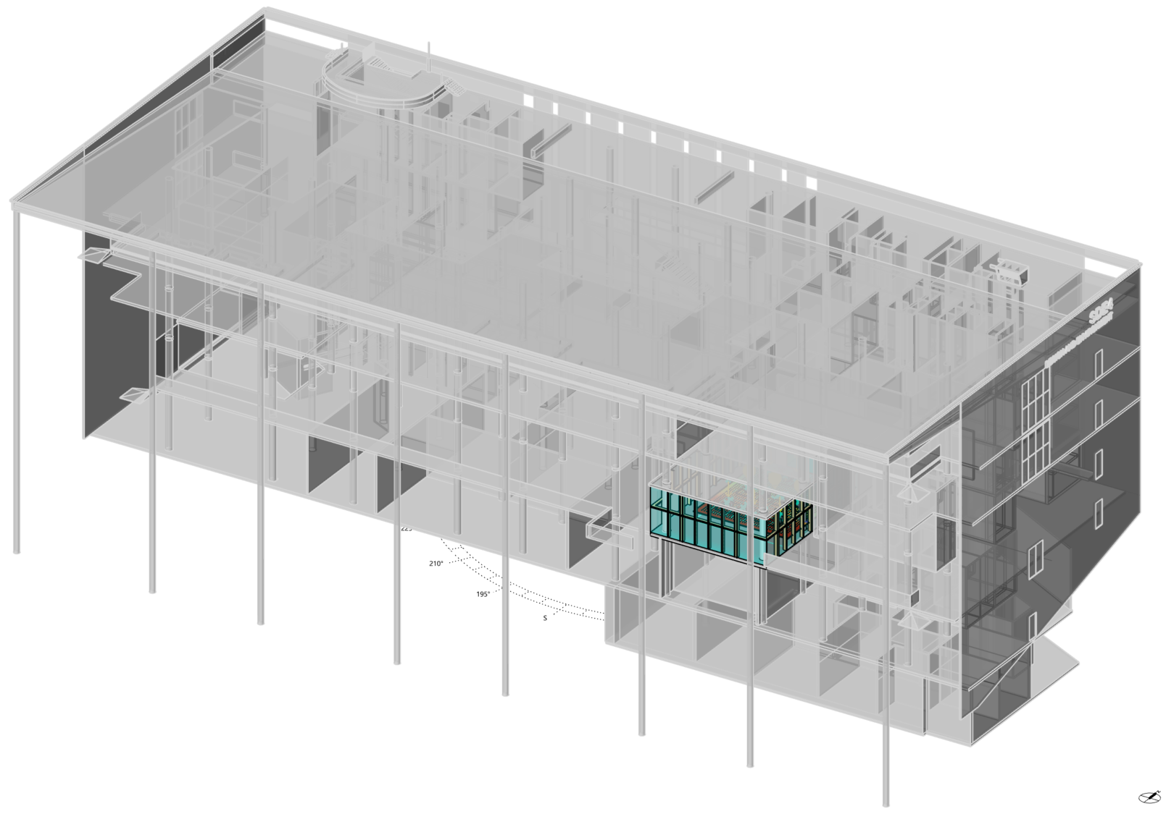 | 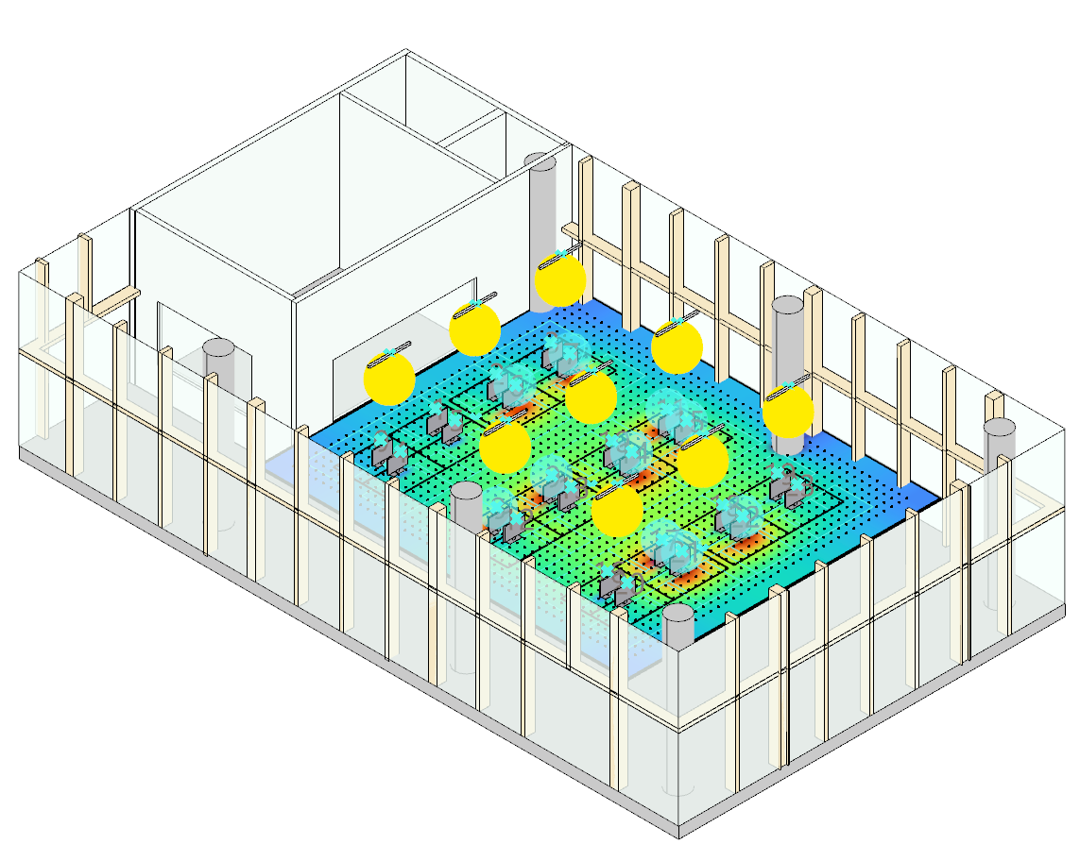
- Location | - Perspective View
Figure 2. the simulated office room within the host building

Simulation scenario matrix
Simulations used three sky conditions labelled Clear, Overcast, and Night. Daylight conditions were referenced to Changi International Airport, Singapore, at 13:00 on 21 March. Overcast used ‘Sky: [Changi.Intl.AP,SG,SGP CIE_Overcast 3.21.13.00]’, Clear used the corresponding clear-sky setting, and Night excluded daylight. Occupancy count ranged from 1 to 15 and five seating layouts were randomly selected at each count. The same 75 seating layout cases were evaluated under all three sky conditions, yielding 225 matched scenarios.

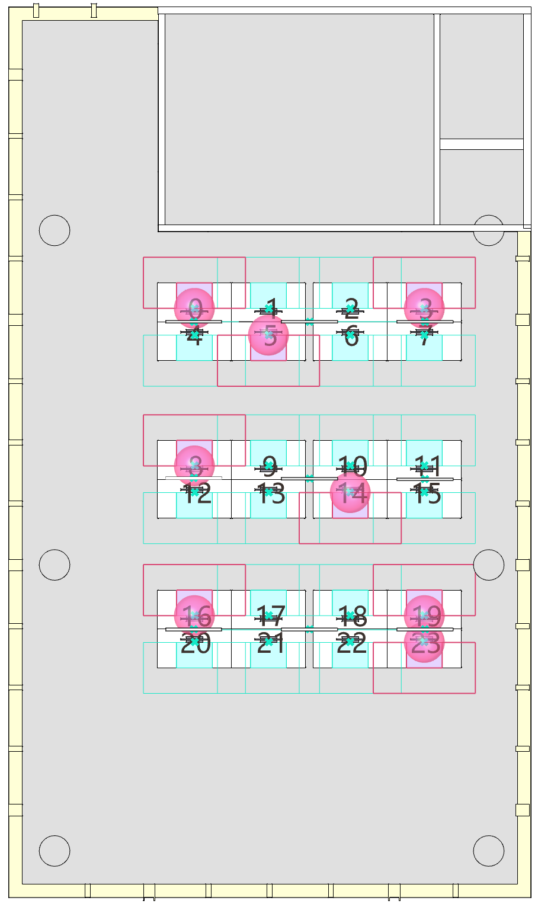 | 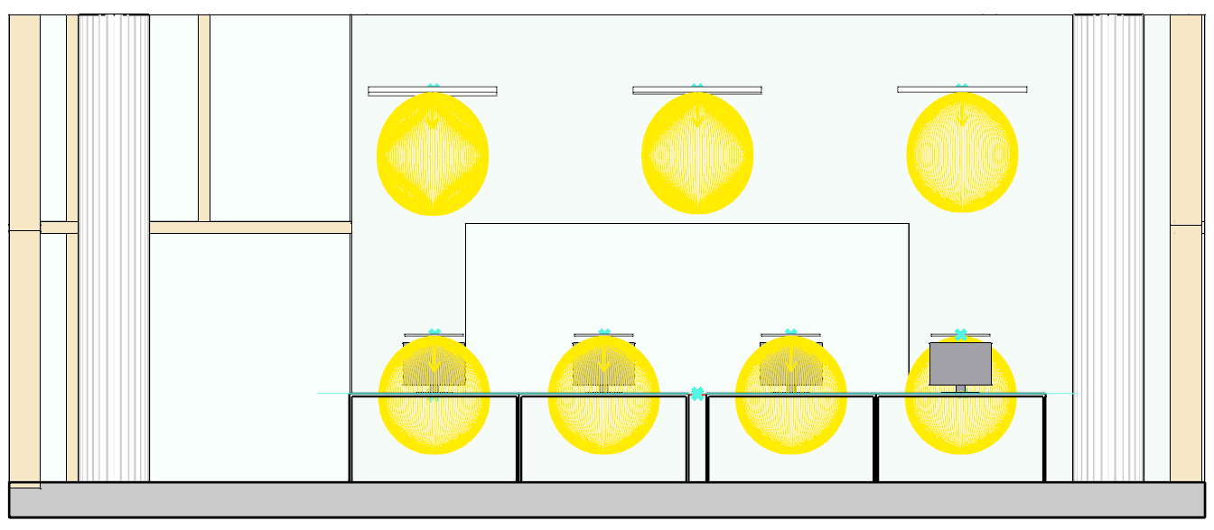
 | - Front View
 | 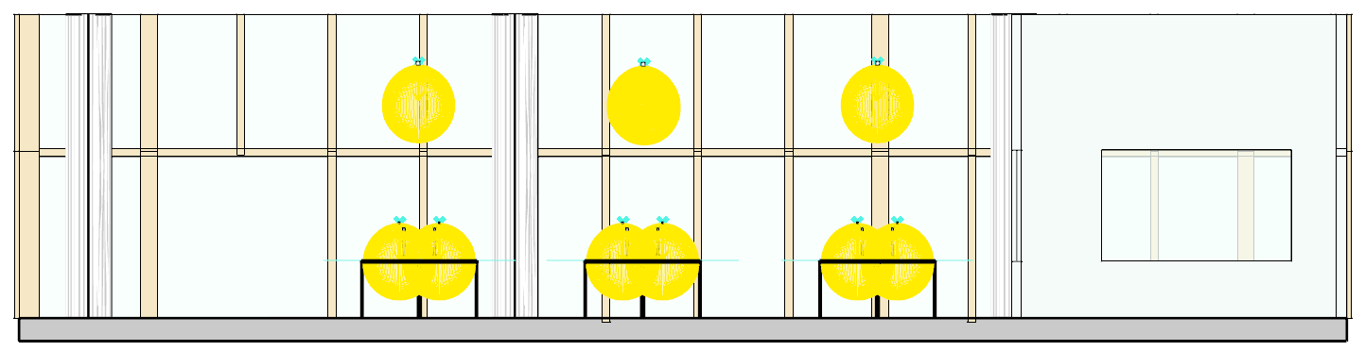
- Top View | - Right View
Figure 3. Room-scale simulation model, seating layout, ceiling light, and task-light arrangement

Decision variables and lighting power for genetic algorithms
The simulated luminaires matched the low power ceiling (each ceiling-zone level added 13.2 W) and task lights (Each task-light level added 1.5 W) currently installed in the laboratory. Total lighting power was calculated as:
P = 13.2 Σⱼ₌₁³ Lc,j + 1.5 Σᵢ₌₁²⁴ Lt,i . (1)
Here, P is the total lighting power in watts; L_{c,j} is the discrete output level of ceiling-light zone j; and L_{t,i} is the discrete output level of task light i. The indices j = 1, ..., 3 and i = 1, ..., 24 represent the three ceiling-light zones and 24 work tables, respectively. For an unoccupied workstation, Lt,i = 0.

Visual-comfort constraints and objective function for genetic algorithms
Visual-comfort requirements followed SS 531 (Singapore Standards Council 2006). Occupied task areas required at least 750 lux and uniformity Emin/Eavg ≥ 0.70. Surrounding areas required at least 500 lux and uniformity ≥ 0.50.

We applied the Ga to minimize a scalar fitness function combining total lighting power with quadratic penalties for unmet illuminance and uniformity requirements. For each performance metric, the normalized shortfall was calculated as:
 | 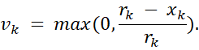 | (2)
where x_{k} is the simulated value of metric k, r_{k} is its required threshold, and v_{k} is the normalized shortfall. A requirement that was satisfied produced v_{k} = 0; otherwise, the shortfall increased with the relative deficit. According to the visual comfort requirement, the required thresholds were 750 lx for E1, 500 lx for E0, 0.70 for U1, and 0.50 for U2. Then, we used a quadratic penalty exponent and a power-dependent scaling factor s = max (1, P). The fitness was:
(3)
Here, F is the scalar fitness minimized by Galapagos, P is the total lighting power, and s scales the penalty weights relative to the power magnitude. Configuration was feasible when all four requirements were satisfied.

Genetic-algorithm optimization
Figure 4 presents a representative seven-occupant case. It links the Galapagos optimization interface to the corresponding seating layout and simulated illuminance field. We ran the GA in Grasshopper in minimization mode. For each scenario, it searched for combinations of the 27 discrete control variables. ClimateStudio and associated scripts evaluated illuminance, uniformity, and lighting power for each candidate. The retained output was the lowest fitness configuration satisfying the encoded constraints.

Rule-based comparison strategies
Both deterministic comparison strategies were evaluated using the same occupied-seat lists. Their sky and seat lighting levels were predefined to satisfy the same illuminance and uniformity requirements as optimized hybrid control. Under zonal PIR ceiling-only control, task lights and unoccupied ceiling-light zones remained off. Each occupied zone operated at the highest ceiling-light level required by any occupant within that zone. Rule-based hybrid control applied the same zone-level maximum principle to ceiling lighting while assigning a prescribed task-light level to each occupied workstation. Thus, both strategies responded to exact seat locations, but only rule-based hybrid control provided workstation-level local lighting. Their lighting power was calculated using the same formulation as optimized hybrid control.
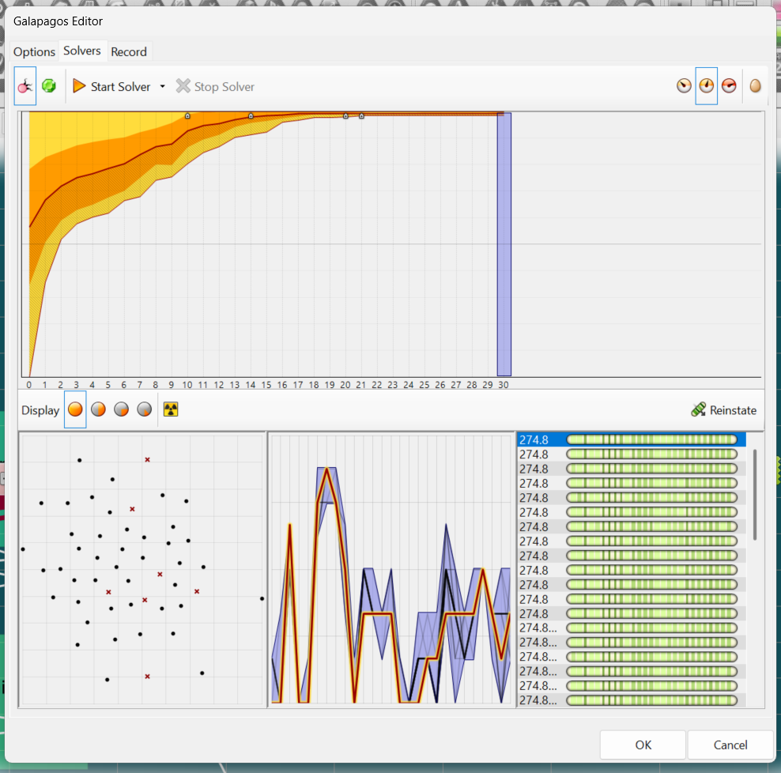 | 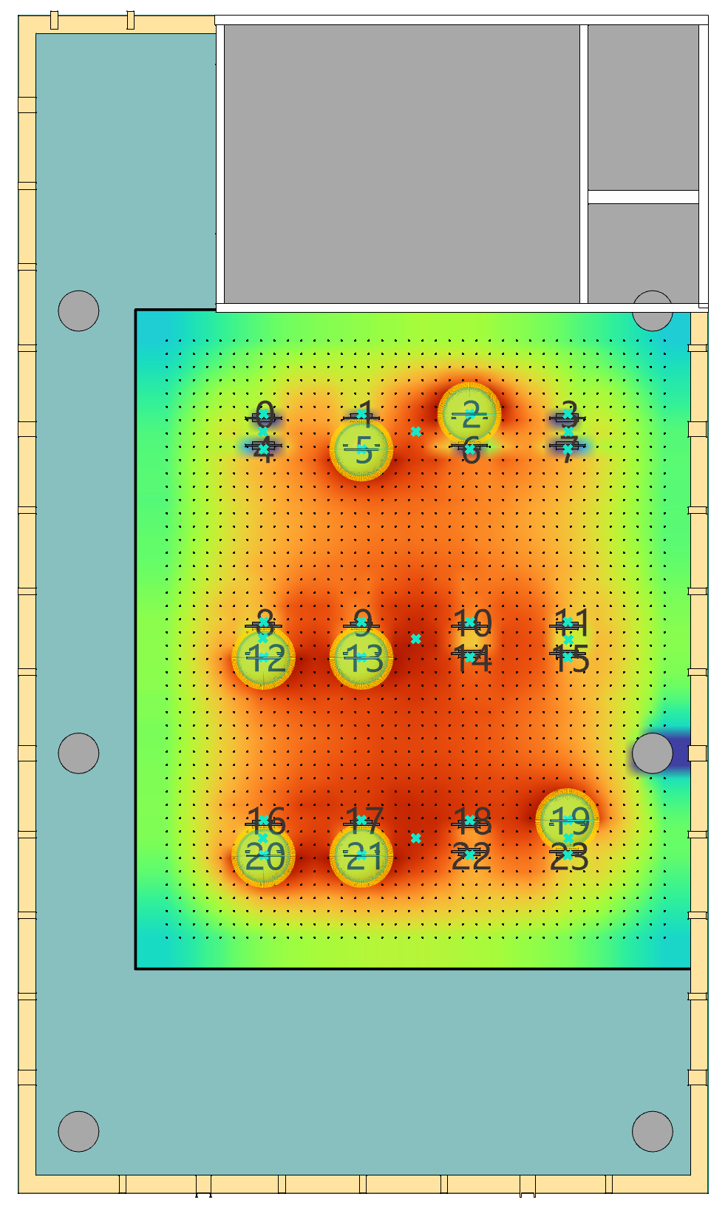
(a) Galapagos interface | (b) corresponding seating layout
Figure 4. Representative seven-occupant optimization
RESULTS
Lighting-power reduction across sky conditions
Figure 5 shows how lighting power varies with occupancy count, with each line representing the mean of five matched seating layouts and each band indicating the corresponding range. Across all three sky conditions, mean power generally increased with occupancy count, while the within-count ranges showed that seating layout also affected lighting demand. Zonal PIR consistently required the most power, with overall means of 75.50 W under Clear, 244.46 W under Overcast, and 443.52 W at Night. Relative to this baseline, optimized hybrid control reduced mean power by 76.9%, 62.0%, and 46.8%, respectively, while rule-based hybrid control achieved reductions of 78.4%, 50.9%, and 29.0%. However, the relative performance of the two hybrid strategies changed with daylight availability. Under Clear, optimized hybrid control remained at a similarly low power level as the rule-based hybrid control. Under Overcast and Night, it used 27.02 W and 78.68 W less power, corresponding to additional reductions of 22.5% and 25.0%. Thus, fixed rule-based coordination was sufficient to approach the lowest power level under strong daylight, whereas optimized coordination provided substantial additional reductions as daylight decreased and the balance between ceiling and task lighting became more consequential.

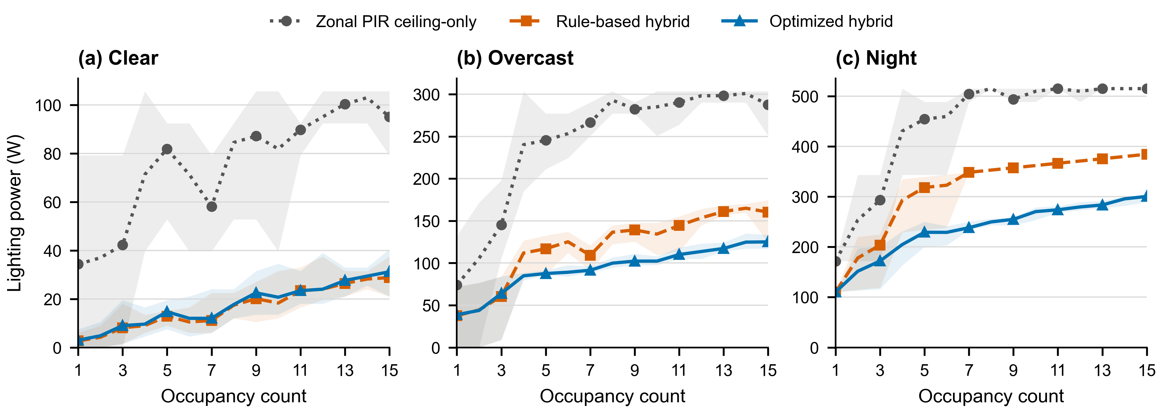
Figure 5. Lighting power versus occupancy counts for zonal PIR ceiling-only control, rule-based hybrid control, and optimized hybrid control
Power allocation between ceiling and task lighting
Figure 6(a) reveals the power-allocation mechanism behind the daylight dependent performance of the two hybrid strategies. Under Clear, both strategies relied entirely on task lighting, resulting in similar mean power levels and leaving little scope for further improvement through ceiling–task coordination. As daylight decreased, optimized hybrid control reduced its reliance on ceiling lighting. Relative to rule-based hybrid control, it reduced ceiling-light power by 25.70 W (29.6%) under Overcast and 84.30 W (30.2%) at Night. Task-light power decreased slightly by 1.32 W (4.0%) under Overcast but increased by 5.62 W (15.6%) at Night, producing net power reductions of 27.02 W (22.5%) and 78.68 W (25.0%), respectively. At Night, the small increase in localized task lighting was therefore associated with a much larger reduction in ambient ceiling lighting. This redistribution, rather than a uniform reduction in both components, explains the additional benefit of optimized hybrid control under limited daylight.

The paired comparisons in Figure 7 show that these mean differences were consistent across individual scenarios rather than being driven by a small number of extreme cases. Optimized hybrid control used less power than zonal PIR in 217/225 scenarios. Relative to rule-based hybrid control, it used less power in only 7/75 Clear scenarios, compared with 60/75 Overcast and 69/75 Night scenarios. The advantage also became more consistent as occupancy increased. Under Overcast, optimized hybrid control was lower in 59/60 scenarios with 4–15 occupants, with the remaining scenario equal. At Night, all five one-occupant scenarios were equal, whereas 69/70 scenarios with 2–15 occupants were lower and one was equal. These results indicate that optimized coordination becomes most valuable when limited daylight and multiple occupied workstations create opportunities to replace shared ceiling lighting with localized task lighting.

Effects of occupancy count and seating layout
Lighting power under optimized hybrid control generally increased with occupancy count. From 1 to 15 occupants, it rose from 3.0 to 31.2 W under Clear and from 38.8 to 125.1 W under Overcast. At Night, it rose from 110.1 to 300.4 W. The trajectories did not increase at every successive occupancy count because seating layouts activated different ceiling-light zones and received different daylight. At a fixed occupancy count, the mean minimum–maximum range across five layouts was 14.6 W under Clear, 24.8 W under Overcast, and 31.4 W at Night. The corresponding ranges were 44.9, 59.8, and 60.7 W for zonal PIR, and 12.5, 38.9, and 35.2 W for rule-based hybrid control. Seating layout therefore influenced every strategy, and occupancy count alone did not determine lighting power.

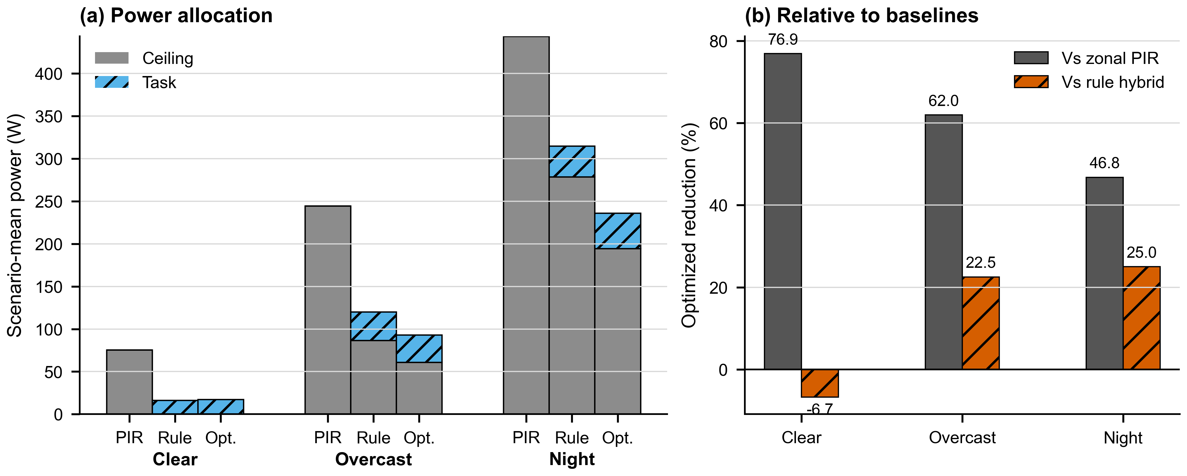
Figure 6. Power allocation and comparative reduction across sky conditions
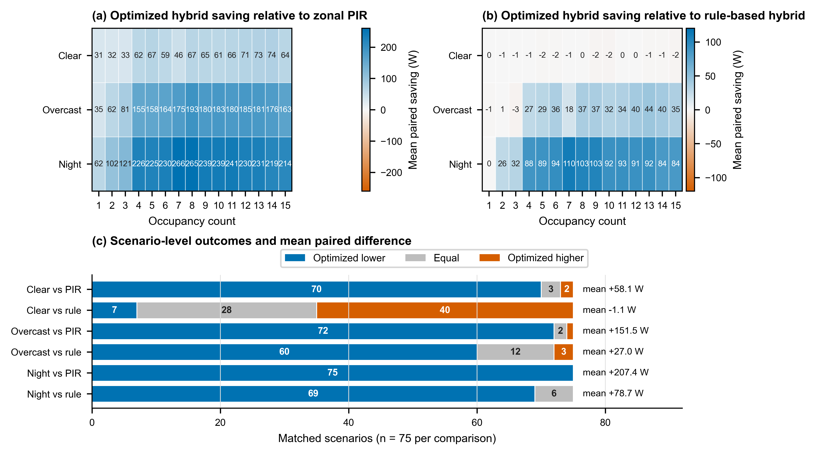
Figure 7. Paired strategy evidence across sky condition and occupancy count

DISCUSSION
Comparison across the three sky conditions shows that coordinated ceiling and task lighting can reduce power under different levels of daylight availability. Under Clear, daylight supplied the background illumination and both hybrid strategies relied on task lighting. Under Overcast and Night, ceiling lighting became necessary, and the retained configurations used localized task lighting to limit ceiling demand. The framework therefore exposes how the power-efficient ceiling–task balance changes with sky condition.

Comparison with rule-based hybrid control separates the benefit of coordinating two lighting layers from the additional benefit of optimized settings. Rule-based hybrid control was slightly lower under Clear, where both strategies kept ceiling lighting off. Optimized hybrid control became consistently favorable from 4 occupants under Overcast and from 2 occupants at Night. Reduced daylight and multi-workstation occupancy created more opportunities to substitute localized task lighting for shared ceiling lighting. The preferred control setting should therefore respond to sky condition and seating layout.

Seating-layout effects also have a direct sensing implication. A controller based only on occupancy count would assign identical settings to spatially different cases, although zone activation and daylight exposure changed power substantially. Practical implementation therefore requires at least zonal location information and may benefit from workstation level sensing. The simulated controls used exact occupied seat IDs, while conventional zone-level PIR sensing would provide less spatial details.

The study represents one office geometry, three static sky conditions, and five seating layouts per occupancy count. Results describe simulated lighting power rather than annual energy and do not include perceived comfort, sensing uncertainty, control delay, or hardware dynamics. These factors require separate validation before implementation.

CONCLUSION AND IMPLICATIONS
This study demonstrates that coordinating ceiling and task lighting can reduce lighting power beyond conventional zonal occupancy control while maintaining visual comfort. The main contribution is an operating principle rather than a single universal setting: task lights should meet localized workstation demand, while ceiling lighting should provide only the ambient illumination that daylight and local lighting cannot supply. And the appropriate balance depends on operating conditions. Fixed rule-based coordination approached the lowest power level under Clear, whereas optimized coordination became more valuable as daylight decreased and more workstations were occupied.

For building designers, the findings support combining zoned ceiling lighting with individually controllable task lights and considering occupant location rather than occupancy count alone. For owners and operators, a staged control strategy may be appropriate: simple hybrid rules can serve strongly daylight periods, while more responsive ceiling and task lights allocation can be applied under limited daylight or distributed occupancy. The optimized configurations provide a performance benchmark for developing and commissioning such practical control rules. This approach can reduce shared ceiling-light demand while preserving localized lighting for occupants.

For researchers, the Balanced Light Control Framework provides a structured method for separating the effects of daylight, occupancy count, and seating layout when comparing lighting controls. The findings are most directly applicable to offices with zoned ceiling lighting and controllable task lights, but the central–local coordination principle may also inform classrooms, libraries, and shared workspaces. Application to other settings requires recalibration for room geometry, daylight conditions, installed luminaires, occupancy patterns, and visual requirements. Future work could extend the present power-based simulation to annual operation and field evaluation.

REFERENCES
De Korte EM, Spiekman M, Hoes-van Oeffelen L, Van Der Zande B, Vissenberg G, Huiskes G, and Kuijt-Evers LFM. 2015. Personal environmental control: Effects of pre-set conditions for heating and lighting on personal settings, task performance and comfort experience. Building and Environment 86: 166–176. https://doi.org/10.1016/j.buildenv.2015.01.002.
Lowcay D, Gunay HB, and O’Brien W. 2020. Simulating energy savings potential with high-resolution daylight and occupancy sensing in open-plan offices. Journal of Building Performance Simulation 13(5): 606–619. https://doi.org/10.1080/19401493.2020.1807604.
Papinutto M, Colombo M, Golsouzidou M, Reutter K, Lalanne D, and Nembrini J. 2021. Towards the integration of personal task-lighting in an optimised balance between electric lighting and daylighting: A user-centred study of emotion, visual comfort, interaction and form-factor of task lights. Journal of Physics: Conference Series 2042: 012115.
https://doi.org/10.1088/1742-6596/2042/1/012115.
Singapore Standards Council. 2006. SS 531:2006 Code of Practice for Lighting of Work Places, Part 1: Indoor Lighting. Singapore: SPRING Singapore.
Tekler ZD, Ono E, Peng Y, Zhan S, Lasternas B, and Chong A. 2022. ROBOD, room-level occupancy and building operation dataset. Building Simulation 15: 2127–2137. https://doi.org/10.1007/s12273-022-0925-9.

* Corresponding author email: E1583443@u.nus.edu

